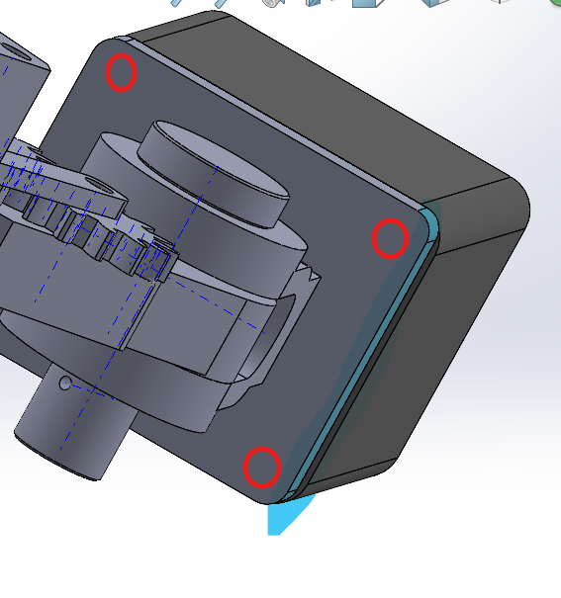
Heated inserts need to be considered and represented. If we intend to just drill it, it will make our design less accurate

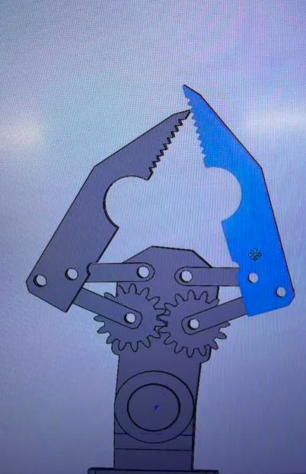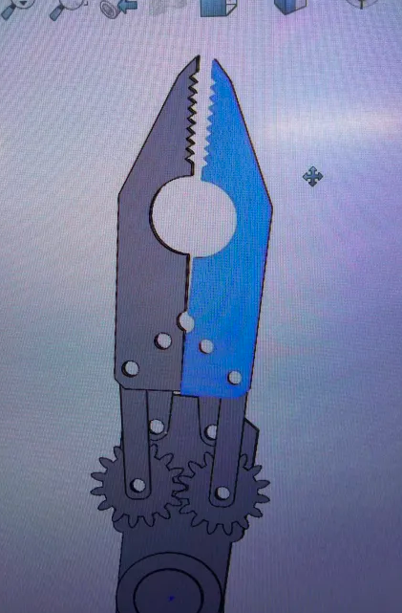
Is this the desired collision between the two gripper components?

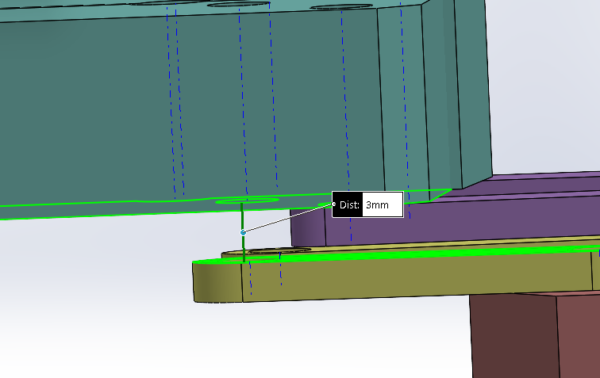
Gap of 3 mm between GRB-007 and LLP-006

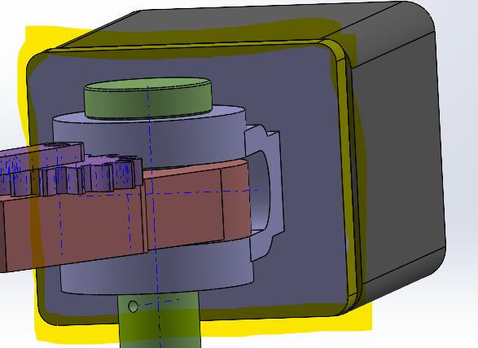
Correct the dimensions of either HAB-001 or MAP-002 for them to be aligned

- Please always check your design with the requirements.

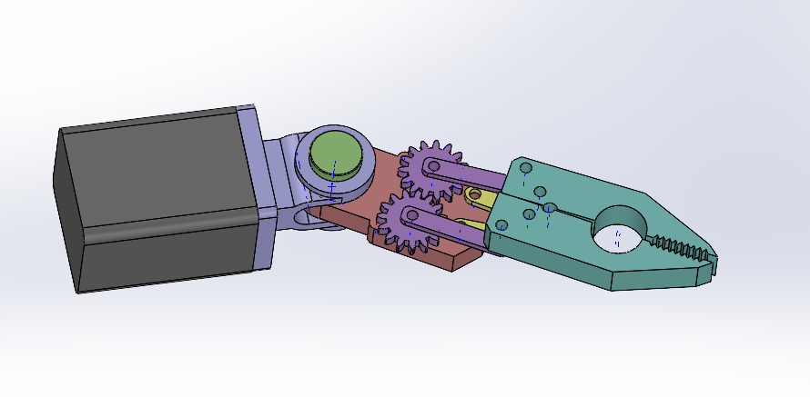
I would appreciate all assemblies to look like this. While it looks silly, it will help you identify each individual component better

Naming convention Chart

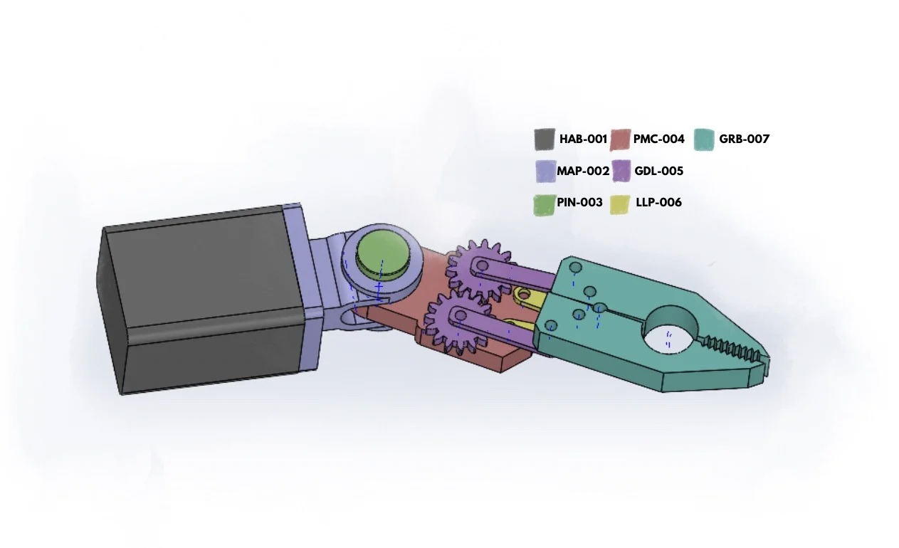
Color | Component Name | Part Number Style | Description / Reason
Dark Gray / Black | Housing - Actuator Body | HAB-001 | Large rectangular base on the left. Contains motor / leadscrew.
Light Purple / Violet | Mount - Actuator Pivot | MAP-002 | The purple block connects the housing to the rest of the mechanism.
Green | Pin | PIN-003 | Pin that allows for rotation.
Red / Brown | Plate - Main Chassis | PMC-004 | The flat red/brown structural plate that supports the gears and linkages.
Purple | Gear - Drive Link | GDL-005 | The bigger purple gear (closer to the actuator) and combined linkage that allows for movement.
Yellow | Little Linkage Pivot | LLP-006 | Small yellow axle/pin connecting the arms to the gears/claw.
Teal / Cyan | Gripper - Body | GRB-007 | The main teal body of the claw (houses the jaws).

